**Day-1**

**7.c program for left factoring**

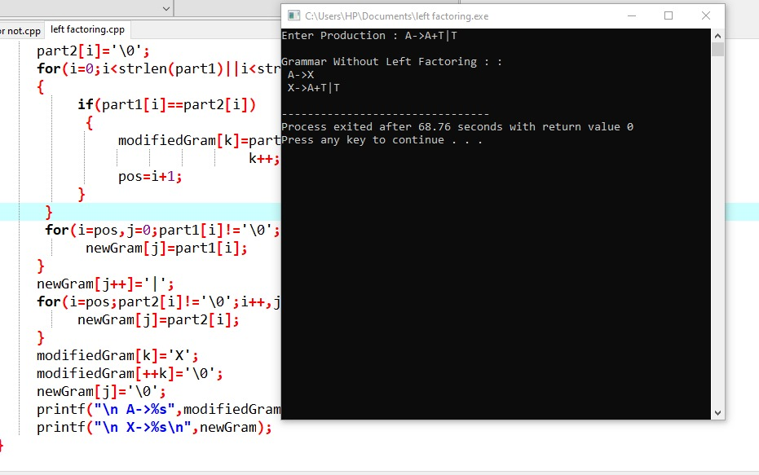

**8.left recursion**

